Day 11 — Broadcast and Accumulators

Create build file
nano build.sbt
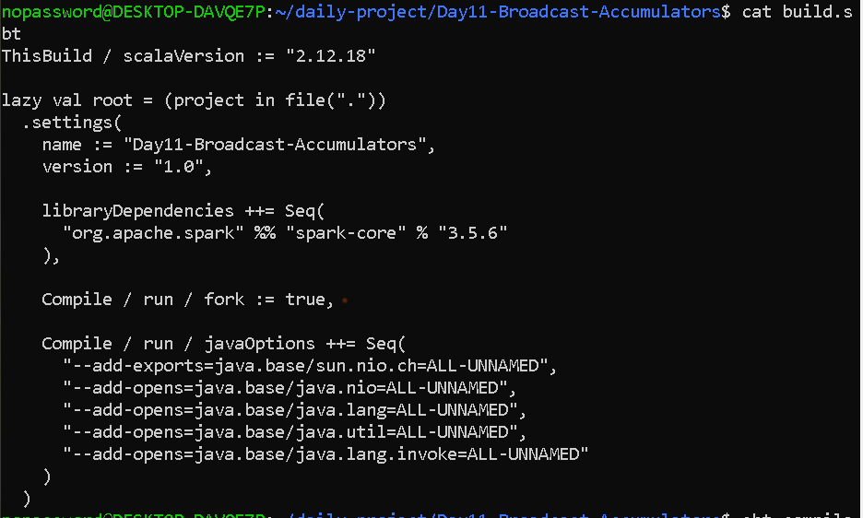

Create Transaction Data
nano data/transactions.txt
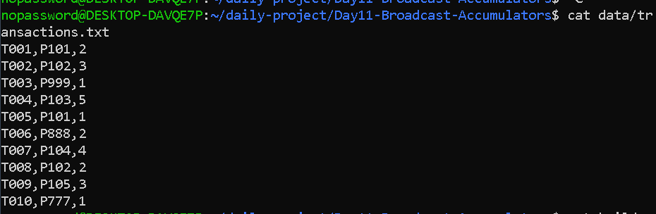

Create the Scala Program
nano src/main/scala/Day11BroadcastAccumulators.scala

import org.apache.spark.{SparkConf, SparkContext}

object Day11BroadcastAccumulators {

def main(args: Array[String]): Unit = {

// ----------------------------------------------------
// Step 1: Create Spark configuration and SparkContext
// ----------------------------------------------------

val conf = new SparkConf()
.setAppName("Day11-Broadcast-Accumulators")
.setMaster("local[*]")

val sc = new SparkContext(conf)

// ----------------------------------------------------
// Step 2: Create a small product master table
// ----------------------------------------------------

val productMaster = Map(
"P101" -> ("Laptop", 55000.0),
"P102" -> ("Mouse", 800.0),
"P103" -> ("Keyboard", 1500.0),
"P104" -> ("Monitor", 12000.0),
"P105" -> ("Headphones", 2500.0)
)

// ----------------------------------------------------
// Step 3: Broadcast the product master table
// ----------------------------------------------------

val broadcastProducts = sc.broadcast(productMaster)

// ----------------------------------------------------
// Step 4: Create accumulator for bad records
// ----------------------------------------------------

val badRecords = sc.longAccumulator("Bad Records")

// ----------------------------------------------------
// Step 5: Read transaction data
// ----------------------------------------------------

val transactions = sc.textFile("data/transactions.txt")

// ----------------------------------------------------
// Step 6: Validate transactions
// ----------------------------------------------------

val validatedTransactions = transactions.map { line =>

val parts = line.split(",")

val transactionId = parts(0)
val productId = parts(1)
val quantity = parts(2).toInt

val products = broadcastProducts.value

if (products.contains(productId)) {

val product = products(productId)
val productName = product._1
val price = product._2

val totalAmount = quantity * price

s"$transactionId | VALID | $productId | $productName | Quantity=$quantity | Total=$totalAmount"

} else {

badRecords.add(1)

s"$transactionId | INVALID | Unknown Product=$productId"
}
}

// ----------------------------------------------------
// Step 7: Trigger Spark execution
// ----------------------------------------------------

val results = validatedTransactions.collect()

// ----------------------------------------------------
// Step 8: Display results
// ----------------------------------------------------

println("\n===== TRANSACTION VALIDATION RESULTS =====")

results.foreach(println)

// ----------------------------------------------------
// Step 9: Display accumulator value
// ----------------------------------------------------
println("\n===== DATA QUALITY SUMMARY =====")

println(s"Total Transactions: ${transactions.count()}")
println(s"Bad Records: ${badRecords.value}")
println(s"Valid Records: ${transactions.count() - badRecords.value}")

// Step 10: Stop Spark
sc.stop() }}
OUTPU—
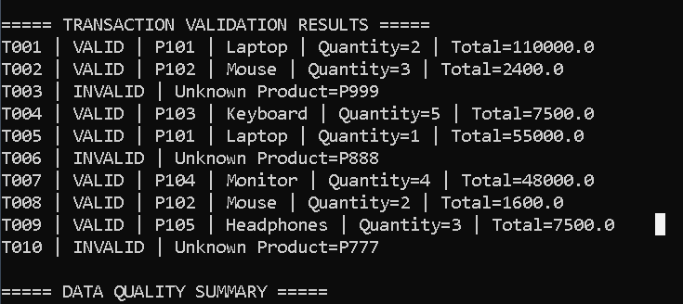

===== DATA QUALITY SUMMARY =====
Total Transactions: 10
Bad Records: 3
Valid Records: 7

